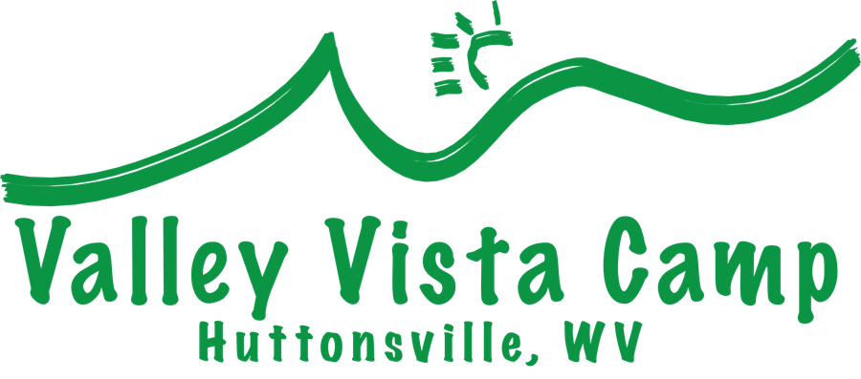
Photo & Video Release
PERMISSION FORM
Periodically, campers participating in summer camp activities may be photographed, filmed, or interviewed. We need your signed permission for your child to be photographed, filmed, or interviewed as it applies only to promotion for the Valley Vista Summer Camp program.
Yes, I give permission for my child to participate in photographs, films, or interviews as they pertain to Valley Vista Summer Camp and I understand that such pictures, films, or interviews may be used to promote or publicize the VALLEY VISTA SUMMER CAMP program or events.
No, I do not allow my child to be photographed, filmed, or interviewed (please tell your child that he/she is NOT to be involved in any Valley Vista publicity, so he/she knows).

Your child’s name __________________________________________________

Parent/Guardian’s
Signature________________________________________ Date _____________

